Chapter 11 The pairing principle (draft 6-15-03 )
The two-domain construction of enzymes is an example of what has been called “the pairing principle”. It appears to have the advantages of the opposed thumb as a source of mechanical force. It became apparent first in the x-ray-diffraction picture for myoglobin as a means by which the protein conformation can regulate the redox potential and thus the oxygen binding at heme iron through adjustments in length and angles of the bond from heme iron to proximal histidine and the displacement of the iron ion from the mean porphyrin plane. The stress developed in this displacement is physiologically significant but produces maximum displacement of the iron ion from the mean porphyrin plane less than 0.7 Å, still a large number for a protein. Moffitt et al detected significant changes in hemoglobin at 0.2 Å on change or iron valence and spin state using difference Fourier comparisons.
Figure 1. Hemoglobin palindrome picture.
The C-2 symmetry of the single subunits of hemoglobin is illustrated in Fig.16. The palindromic petals through their several connections to the heme group coordinate and control heme electronic properties with protein conformation. As with the expansion-contraction process in enzymes the conformation changes responsible for functions in myoglobin proteins are undoubtedly dynamical. The versatility of this device was explored using cytochrome C to provide a general model using ligand-field theory for the functional interactions of metal ions with conformation. Like the heme proteins the static and dynamic properties of metal ions in enzymes are modulated by conformational constraints on bond lengths and bond angles However, hemoglobin is a a poor model for metal enzymes.
Pairing of functional domains nearly ubiquitous in enzymes is also found in proteins with other kinds of functions and can be easily detected even when accurate B values are not available. Just as the existence of B-factor palindromy implies a two-fold rotation axis between paired catalytic domains, the presence of that symmetry implies the existence of palindromy in the knot B factors. Functional domains other than functional pairs can complicate detection of the symmetry but even a casual examination of collections of protein structural information reveals the C-2 symmetry to be very common. Its presence in non-enzymic proteins suggests that the high precision and accuracy of the palindrome found in enzymes has a more general role in biology. For example the coordinated expansion-contraction of matrix pairs itself dependent on the B-factor palindrome may generate mechanical force for other physiological processes
The a and b parts of the Fab fragments of IgG appear to be related by two-fold rotation symmetry. However in contrast to most other kinds of proteins the knots and matrices are not clearly distinguished. Judging from the digoxin antibody-antigen complex many B values switch from low to high values and vice versa. All B factors are low suggesting a different kind of substructure. There are now enough new data for immunological proteins for biochemists to begin exploration of that possibility.
Symmetry is very useful in detecting palindromes but does not much distinguish one protein family from another. It does reveal that the palindromic matching of pairs of functional domains persists in very complicated proteins. Thus, for example, the large family of TIM-barrel proteins has five such symmetry-matched pairs each of which is thought to add or enhance some feature of the function. The pairs are separated into two sets each of which contains one member of the five pairs. The sets are fused into a single functional domain by H bonds between short peptide segments so as to give the whole a very extended B-factor palindrome and dyad symmetry. The assemblies form a hinged torus with dyad symmetry and a very extensive B-factor palindrome. Atoms in the H bonded segments have knot B values and form laddered secondary structures having characteristics of both BPTI and contiguous-chain knot classes.
The proteosome shown in Fig. @ consists of three matched pairs arranged with C-2 symmetry to form a long tube in which unfolded polypeptides are hydrolyzed. The pairs interact cooperatively so several hydrolysis steps occur either in peristalsis along the tube axis of in single mechanical events almost certainly the familiar expansion-contraction process. The polypeptide is thought to be fully extended and it is possible that the device minimizes substrate specificity so as to be applicable to many polypeptides
The next degree of complication is illustrated by aspartyl transcarbamoylase, in which the paired functional domains are on different and separable subunits. The HIV-1 protease is a rudimentary example of this kind of construction and well explored. The “iron” protein from the nitrogenases has precise C-2 symmetry in its catalytic domain pair with a small separated metal cluster forming the hinge. Each domain has one of the large coenzymes and some of the function-related conformation changes are detectable in x-ray studies. It is likely that the expansion-contraction process of the total matrices is coordinated with the many steps of proton and electron transfer for chemical cooperation between the two domains. The expansion-contraction process is a simple way to couple allosteric sites but less extensive conformational changes may also provide coupling. Similarly more complicated multiple-protein enzymes like aspartyl transcarbamoylase with catalytic functional domains on different proteins may use different devices to couple the cooperating protein subunits. The palindromy, domain-closure and symmetry characteristics may be quite different but it has the usual C-2 symmetry. Note again that the T1 nuclease shows that exact C-2 symmetry is not necessary in enzymes; that may also be the case in other protein families. There are several other enzymes that hydrolyze ribonuclease A and thugh all appear on first examination to have distinctly different construction, all do have the invariant construction features just discussed. Examples fro this family are discussed in the Conclusion section.
All the enzyme-data we have thus far examined reveal the same set of constuction principles with some minor modifications but no omissions. If there are major deviations it is surprising that not one has yet appeared. The invariant set includes the pair of extraordinarily matched functional domains arising from the exact C-2 symmetry and thus the B-factor palindrome of the knot atoms. Each of these domains carries at least one chemical functional group. In the trypsin and pepsin families there are only two of the latter. These are acid or basic groups able to form a hydrogen bond between domains and apparently intimately involved as a mechanical-chemical transducing device in catalytic function.. The chemical functional groups are generally attached to knots near the hardest part of the knot. The suggestion is that the latter are anvils through which the force of contraction is applied to the reacting assembly. Beyond the last conjecture the details are less clear. Each new protein examined adds new features that improve the general understanding.
. The following examples illustrate the construction principles.
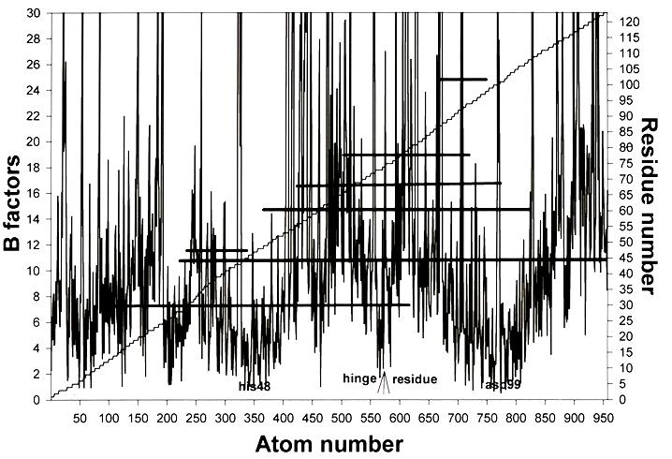
Figure 2 Phospholipase A2. The dyad axis is perpendicular to the helix knots. Extensive helix knots are rare in mezophiles. 7 disulfides connect the two catalytic domains, there is a third domain for ion binding. Three of the disulfide groups are the hinge. The two functional groups break out of the helices thus breaking the helices at those points but only at those points. Substrates lie inside the protein on top and parallel to the helix knots. As in ribonuclease T1 the role of disulfide bonds is exaggerated.
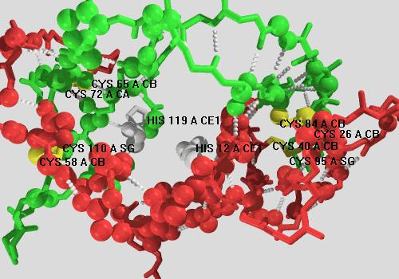
Figure 3. Ribonuclease A This enzyme has close C-2 symmetry in its catalytic pair of functional domains but its construction depends at least as much on disulfide bonds as on the knot peptide-peptide H bonds. The protein is shown as two separated functional domains. The polypeptide resembles a coiled rope and there is a disulfide at each end of each coil as shown in yellow. This dependence is unusual and make it difficult to view the symmetry with precision. It has all the features found in the construction of other enzymes but the domain-closure coordinate is somewhat different to accommodate the ribonuclease coiled substrate.
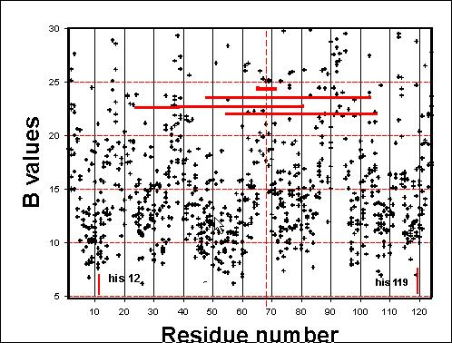
Figure 4 B-factor plot for ribonuclease A showing distored symmetry and the positions of the disulfide bonds. (in red). This is a very complicated construction but consistent with the general rules for enzyme construction. Enzymes like this with large polymeric subtrates generally have special construction features as required by the substrates. The HIV-1 protease has a latch that closes about the substrate (see Fig.?)
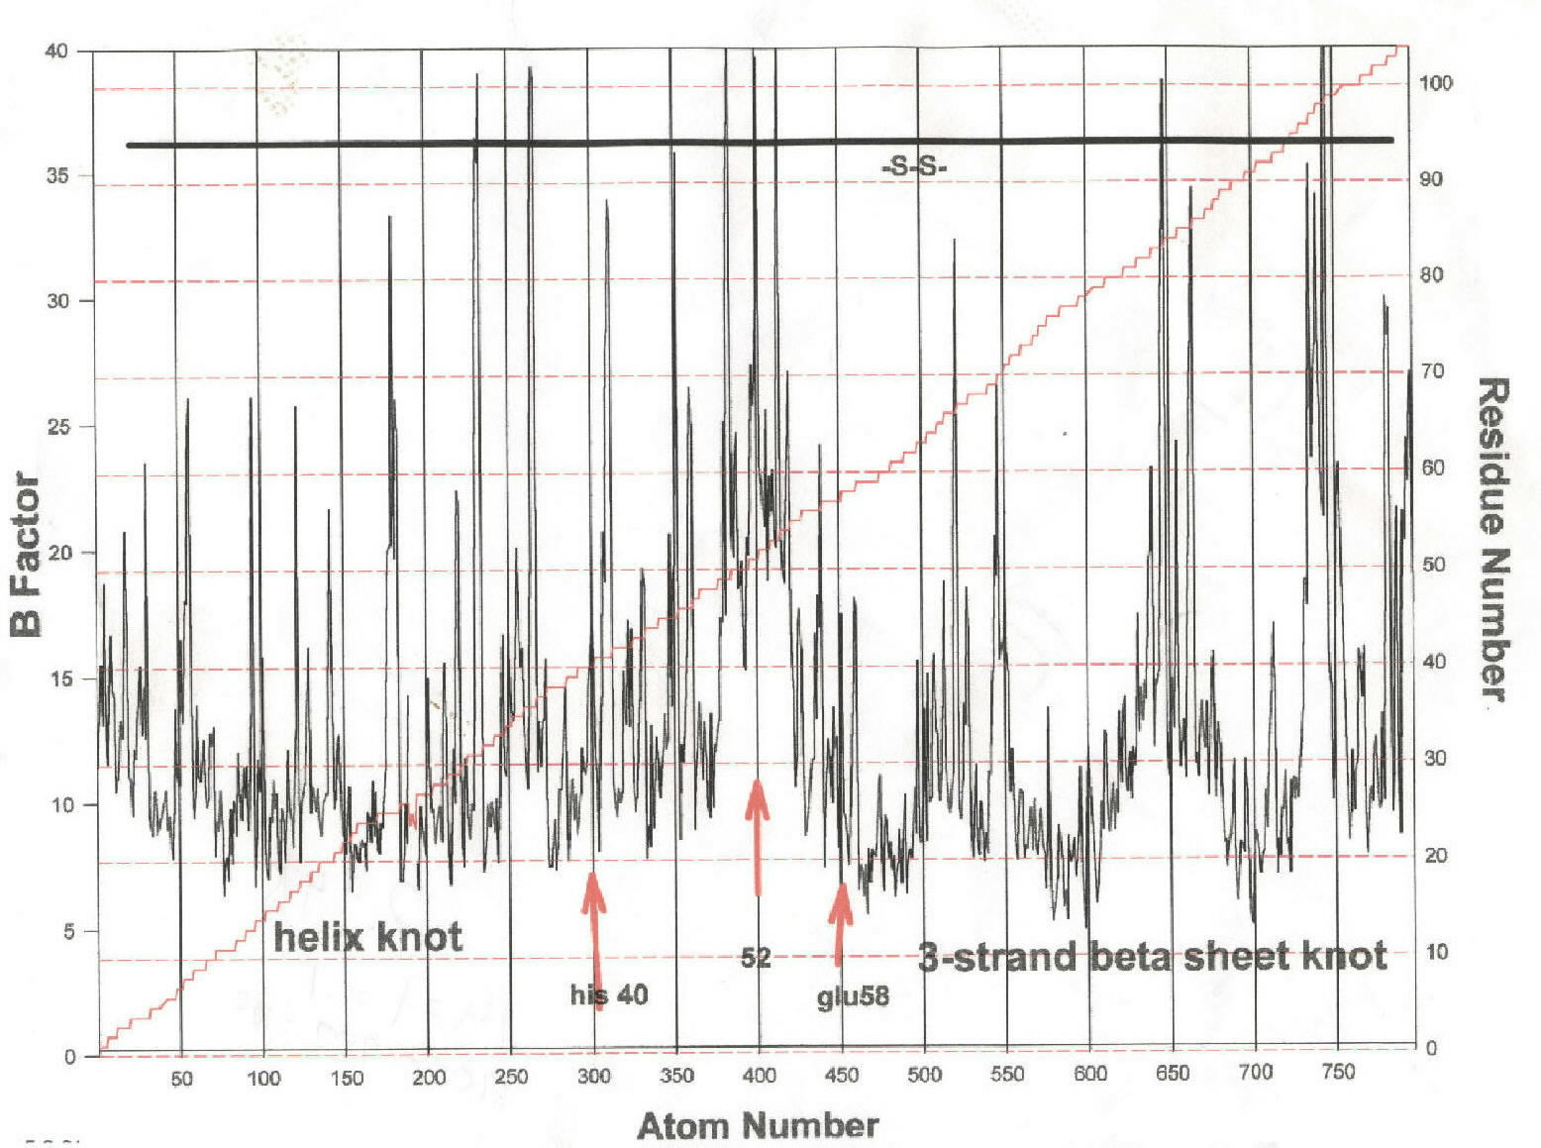

Figure 5. Ribonuclease T-1. This construction is especially rare but very important in showing that exact C-2 symmetry is not always necessary in enzymes. The knot of one domain is a helix and the other a three-strand antiparallel β sheet. The functional groups are shown. Although the domains are probably very closely balanced dynamically, they do not resemble a tuning fork as is usual for other enzymes. It would be interesting to find an example of this family with either all helix or all sheet knots. At present there are none in the PDB

