Chapter 15 Structural similarity of proteins.
Despite the common occurrence of C-2 symmetry and the closeness that is approached usually to single-residue positioning, it is unlikely that evolution of enzymes proceeds to perfect C-2 symmetry in the knots nor is exact C-2 symmetry at single-residue positioning likely given the limited number of variables available. It is either essential in the construction and function of most proteins or an artifact of something more fundamental. As x-ray-diffraction precision improves increasingly the symmetry will be found to be imperfect although apparently good enough for near maximum efficiency in supporting function. However, there are a few examples from the PDB showing that the general construction pattern is either less necessary for maximum efficiency in function or that evolution has not yet advanced to maximum efficiency. Since all enzymes appear to have evolved to reach the same set of construction details apparently most following independent paths, it is not obvious that their evolution is incomplete. Three examples show large deviations from that symmetry and undoubtedly more will be found. T-1 nuclease was the first example it was particularly important since it showed that domain closure is catalytically effective without precise knot C-2 symmetry. Instead it has average B-factor matching of the two catalytic domains to the same mean B factor over knot sequences of the same length. One of its knots is embedded in helix the other embedded in antiparallel β sheet. Nether knot is formed from a continuous string of polypeptide. Exact B-factor palindrome is not possible (Fig.@). The knots appear to be large but the actual number of atoms in these H-bond- dominated structures is within errors the same fixed fraction of total atoms as in other binary proteins. One might have suspected somewhat larger since one knot is pure helix, generally a weaker knot former, and the absence of exact dynamic balance might require something extra. But similar knot construction is common and the other construction features of enzymes are preserved implying the importance of atom free volume and that the catalytic mechanism is the. same. The two chemically functional groups are slightly displaced from their usual positions along the chain but correctly positioned in space at H-bond separation to take advantage of domain closure. The T-4 lysozyme is very similar again suggesting the possibility that domain closure occurs without C-2 positional symmetry. Ribonuclease has two similar but not exactly matched domains. However the absence of C-2 symmetry in the knot atoms may be the result of special accommodations required by the large polymeric substrates and thus far all these C-2 violators have large substrates.. Ribonuclease A is one of the most studied examples important because the C-2 violation is small and scarcely noticeable until the details of construction are described. Its molecular description is somewhat more convoluted than usual because the disulfide groups play a more dominate role in construction. (Fig. @). The C-2 symmetry is difficult to find in the pictorial description although not in the B factors. The disulfide groups as can be seen in the B diagram lie between the functional domains forming the hinge as in phospholipase A2 in which the disulfide groups sew the functional domains together along their entire lengths still forming the inter-domain hinge. Domain closure appears to occur as usual in this case by bending at the disulfide cross-links despite the strong inter-domain interactions. Ribonuclease A has higher high-temperature stability and lower low-temperature stability than most mesophiles perhaps because of the disulfide cross linking. The single-domain protein BPTI appears to depend about equally on disulfide placement and knot atoms (cf. Fig. @)) and it is possible that its relatively high thermal stability is due to their cooperation. Labile disulfide rearrangments in bubble species does not appear to be a problem. Disulfide crossing is fast and versatile as Huggins et al first demonstrated in 1951 seven years before Kolthoff and coworkers effected spontaneous reformation of the 17 disulfide bonds in bovine serum albumin. The Huggins finding showed that the refolding of the several proteins show by Mirsky and colleagues to have a reversible melting process is thermodynamically driven. Lumry and Eyring pointed this out in 1953 but gained acceptance only when Anfinsen and White demonstrated the restoration of catalytic activity many years later..The studies by members of Northup’s group in the mid-thirties form the beginning of the modern era in protein research. The contribution of disulfide groups to bubble stability and structure is probably minor since it is the polypeptide solubility in bulk water rather than the disulfide groups prevents random-coil production from bubbles quite as affectively as disulfide bonds.. In native forms those bonds as nodes in polypeptides stiffen matrices and since geometric changes in transition-state formation are very small, disulfides remain locked in position up to the transition state. That may increase or decrease the net work required to form the transition state but in order not to interfere in folding they must be at the right place at the right time and must thus be stabilizing. That means that microscopic reversibility must apply for processes driven by free-energy minimization.
The third special protein, actually the entire myoglobin class, has no low B factors and thus none of the strong knots found in most other mesophiles. Rosenberg and Barksdale found that the distribution function for the proton-exchange rate constants is a single peak with a very small slowest-exchange group attributable to the exchangeable protons of the imidazole groups. The mean B value is high and its standard deviation is small nevertheless the lowest B-value atoms, of which there are many, form a well defined palindrome with peptide hinge and domain-pair bridged by the heme group (Fig. @). Myoglobin and the single-chains of the hemoglobins consist of many long helices that exhibit large B-factor palindromes. Factors responsible for thermodynamic stability are not obvious but stability which is low relative to most other mesophiles may depend on whole-molecule helix-helix interactions with considerable dynamic character. Frauenfelder and coworkers have demonstrated with single-chain hemoglobins and myoglobins that there is a rich distribution of conformers to support the ‘’mobile-defect” free-volume rearrangements of Lumry and Rosenberg. Such rearrangements are probably unusually large for this class of proteins because of the absence of strong knots. For example, mercury triiodide was found to be inserted on the proximal side of the heme group in early studies of isomorphous derivatives. The B factors in ferrous hemoglobins are large but with a small standard error consistent with averaging among the many conformers of Frauenfelder et al. On cooling to 100K the average atom B factors drop to very low values The protein is different in character from most others so far examined but the cyanide derivatives of ferric hemoglobins and particularly of ferric myoglobin have somewhat lower B values at 298K for apparently fixed knots. This strong ligand may “normalizes” the structures of this myoglobin-fold protein .However hemoglobin is the one protein class we have found for which a “fragile” (non-Arrhenius) free-energy surface is indicated.
In general conformational rearrangements of knots when possible without destroying folded stability require crossing of high potential energy barriers due to rearrangement of some minimum of the strong hydrogen bond units responsible for knot stability. Relaxation among conformers so produced is of the Arrhenius type, i. e; exponential rate law. Liquids with potential-energy surfaces with such high barriers are often called “strong”. Matrices on the other hand at least in expanded states almost certainly correspond to “fragile” liquids in having rough surfaces with many low barriers and thus considerable non-exponential relaxation. The absence of low B factors and the conformer relaxation behavior found in the relaxation studies of the Frauenfelder group show predominant fragile character as is consistent with the absence of low B factors and with the ease of free-volume rearrangements. The major group of conformers is probably that in which the helices are shifted slightly as a plastic bundle. The bundle can be soft yet have considerable cohesive strength. For myoglobins and hemoglobins the compensation temperatures cluster about 290K and none near 354K or 450K have thus far appeared The 290K compensation temperature is only weakly temperature dependent meaning that the enthalpy and entropy differences among the major conformers are due to changes in potential energy plus zero-point energies and degeneracy rather than differences in excited–state populations. In proteins with strong knots matrix transitions may be considerably constrained.
Further searching of protein databases will reveal other acceptable modifications of the basis construction pattern. For example, streptavidin (@insert organism name) consists of 134 residues in two functional domains of equal size and nearly all in antiparallel β sheet conformation. They are connected longitudinally by many H bonds to form a continuous cylindrical tube in which the very strongly bound biotin molecule sits but the single knot is entirely confined to one domain and it is in that one that biotin is fixed.. Or another example by comparison of subtilisin BPN’ with proteinase K to find that although they are thought to be members of the same protein family, their B-factor palindromes are not quite exact. Two of the knot H bonds are in slightly different positions in symmetrical adjustments that maintain C-2 symmetry.
Proteins consisting of single functional domains appear to have relatively simple functions sometimes involving primary-bond formation between protein and inhibitor but the subtleties reflecting the subtle-change process of matrices do not appear to be common. Modern enzymes on the other hand probably always depend on that matrix process; we have found no exceptions. They manifest as a group a single set of qualitative construction principles and share the common knot compensation temperature of 354K and that of matrices in the 400-500K region. The two catalytic functional domains in expanded-matrix states appear to demonstrate these temperatures independently but the relevant data are insufficient to establish that principle. These characteristics are consistent with the fact that in each functional catalytic domain regardless of protein size there is a fixed fraction of total residues in knots and a fixed fraction in matrices. These features are also frequently found in non-enzymic mesophiles. As already observed, it is our opinion that these features are due to the evolution of the physiological functions of the protein rather than any intrinsic manifestation of DNA expression so the catalytic mechanism is far superior to the alternatives evolution has explored..
Certain reasonable deductions can be made immediately on the basis of these invariant construction features and the prevalence of C-2 symmetry or what we can call pseudo C-2 symmetry in proteins with major physiological functions such as enzymes, immune proteins, ubiquitin, chaperons, ferridoxin, ligand binding and membrane receptors, membrane transfer and signaling proteins to name a few. As indicated by the nearly ubiquitous non-crystallographic C-2 axes, two of the functional domains form a pair matched in size, positions of low B atoms and in expansion-contraction characteristics. The expansion-contraction processes as illustrated by enzyme function arise from precise patterns of coordinated free-volume change; first-order phase changes due not to intrinsic characteristics of polypeptides but rather to selection of matrix residues one by one. Those processes interconvert conformational enthalpy and entropy with small essential changes in free energy. Lumry and Eyring suggested that this is the basis of protein function and now it can be seen to be the basis for matrix participation. The reasons for such successes in natural selection are obviously mechanical not different in kind from the opposed thumb in depending on the manipulation of force vectors rather than major utilization of heat. The need to manipulate free-energy changes and static stress mechanically as vectorial quantities is one major reason why proteins are so large. Familiar chemistry is concealed in unfamiliar devices rather than in logical extensions of small-molecule chemistry so often expected but so rarely found. The criterion for precision in palindrome construction for knots estimated using highest protein x-ray-diffraction resolution is about 0.1 Å thus just below function-related changes in primary-bonds and qualitative differences in hydrogen-bond character. The free-volume changes of this size, easily measured in crystals using crystal B factors, are dependent on protein activity coefficients and the degree of advancement of the ubiquitous expansion-contraction process. Free-volumes are much more sensitive to activity coefficient changes than coordinates so the free volumes in crystals may be inefficient estimates of free volumes in solution. Thus, for a example the use of sulfate ion, polyethyleneglycol and other effective precipitating agents will generally yield smaller estimates of free volumes in crystals than exist in solution. effecting quantitative changes in functional parameters
The mechanical hypothesis of enzymic catalysis advanced 50 years ago by Eyring, Lumry and Spike The C-2 rotational symmetry and the other construction features of enzymes appear to be the essential basis of catalytic function. According to Eyring, Lumry and Spikes the mechanism is mechanical depending of the use of mechanical work for rate acceleration rather than heat. For enzymes the mechanism was first illustrated with chymotrypsin as shown in Figs. 26. but with some error since there was no x-ray data until many years later do distinguish between the C-2 symmetry and a plance of symmetry shown in this figure..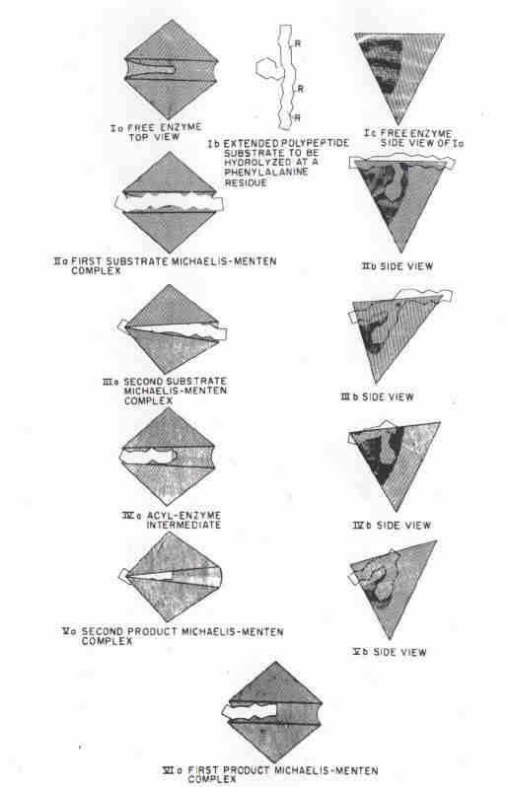
Figure 1 Old chymotrypsin mechanism illustrating the subtle conformation change and the resulting domain closure. This mechanical mechanism was proposed to drive the substrate and the functional groups of chymotrypsin into a compressed pretransition state for catalysis. Pictorial description, much exaggerated of chymotryptic catalysis. Before x-ray diffraction data became available it was thought that the two domains were mirror images as shown here rather than related by C-2 symmetry. Otherwise the pictures require only modification to show the participation of the knot and matrix substructures.
Fig. 26 introduced the concept of pairing of domains and domain-closure but the prevalence of C-2 symmetry in proteins was not suspected and became obvious only after discovery of substructures..Fig. 27 is the up to date description from x-ray diffraction experiments.
. 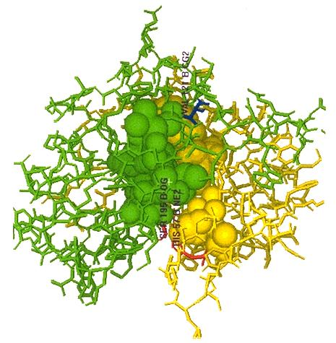
Figure 2. X-ray picture of alppha chymotrypsin. Like other enzymes the substrate and chemically functional groups lie in the cleft separating the two functional domains. There is a single hinge and two functional groups one to each domain. Those are somehow supported by asp 102 and thre 139. The classical “charge-relay” gains its catalytic efficiency as a result of its compression between the two matrices. Asp 102 does not appear to be essential Substrates are bound in the cleft at the bottom in contact with the chemically functional groups show in red. The balls as the knots. (See fig. @ for details)

