Chapter 16. Examples of “nutcracker” mechanisms.
Hemoglobin, cytochrome C and chymotrypsin were the first proteins to be used to illustrate the device by which mechanical stress and chemical free energy can be interconverted to achieve high rates of catalysis and adjustment of oxidation-reduction potentials and ligation isotherms...The mechanism postulated in 1953 under the title “rack mechanism” is more appropriately called “a nutcracker” as Carloni has suggested recently .In hemoglobin the original focus was on on the single tethering bond between metal ion and protein histidine at the proximal position of the heme group and most other heme proteins including cytochrome C by which the position of heme iron in relation to protein conformation adjusts spontaneously in response to changes in mechanical stress in that bond These changes extend into the protein so that lligand affinity, iron redox potential and physiologically useful redistributions of free energy take place through tertiary changes in the single subunits and in the associations of the subunits in hemoglobin.. This proposal gained support from the changes in x-ray-diffraction patterns reported by Perutz et al although those originally emphasized quaternary conformation changes. Takashima and Lumry measured major changes in the dielectric relaxation behavior of hemoglobin but for reasons stll not established these were not confirmed by some other workers. Nevertheless the hemoglobin rack mechanism has been the central feature of most research on that protein although not detailed description of the oxygenation mechanism has yet been established.. A major difficulty is that old ideas die hard. For example the classical ideas about the pH dependence of oxygen binding once seeming reasonable have recently been overturned by Yonetoni et al who find it to be due entirely to the interaction of diphosphoglyceric acid with its contact imidazole groups so that in the absence of the cofactor this Bohr effect nearly disappears.
The central bond in enzymes not requiring cofactors is an H bond between two side chain acid or base groups one on each of the two functional domains. The serine and aspartyl proteinases depend on changes in that bond in response to changes in the forces between the two domains... Enzymes like carboxypeptidase A and some redox proteins like the cytochromes are members of the hemoglobin functional class insofar as the chemical characteristics of the metal ion are modulated by conformational fluctuations. However in contrast to the hemoglobin carboxypeptidase A has low B factors and a well-delineated knot palindrome so is a strong rather than fragile protein... As shown in Fig. @, the zinc ion is attached to one of the catalytic domains by histidine 69 and glutamate 72 and connected by histidine 196 to the second domain. Although there are dispersion associations between pairs of aromatic side across the interface between domains, the only major bond is that from his 196 to zinc ion. X-ray data suggest that that bond is normal for small zinc complex ions in the inactive form of the protein so domain closure by compression produces temporary abnormality such as transient ionization of the water ligand. The several ways in which such coordinate changes can change the properties of a metallic ion or coenzymes are detailed elsewhere using cytochrome C as the example (Lumry, Sollbaken, Sullivan and Reyerson, 1961). To emphasize the control of the strong bonds of complex-ions by the cooperation of many matrix or knot bonds has been called the “Lilliput principle”, a good general description of many protein mechanisms insofar as it implies cooperation between functional centers like metal ions and major fractions of the protein, usually in a dynamic way.
The absence of any special device to use heat for rate enhancement has always been indicated by the low activation energies for the catalytic rate constant so low in fact as to indicate that there must be a large supplement of potential energy from the protein. Koshland developed his “induced fit” mechanism at about the same time as the rack was formulated and at the time is seemed to promise a major role for electron rearrangements by coordination of several of the electronic mechanisms of catalysis studied by physical organic chemists in small-molecule systems. However subsequent experiments, most in fact in subsequent enzyme research, have not provided support for the original promise. Various devices most based on unusual entropy considerations give promise of enhancements of a few orders of magnitude in rates but nothing like the ten or more actual enhancements of rates by enzymes versus maximum catalysis rates in homogeneous solution. Much larger discrepancies have since been report particularly by Wolfenden surprisingly without stimulating a profound examination of the alternatives to the conventional line of attack. The problem with classical physical-organic-chemistry approaches is not the overextension of small-molecule chemistry so much as the failure to give serious attention to the protein. Koshland at least suggested conformation rearrangements to relaxed states with very special electronic behavior in catalysis but almost all enzyme investigators have ignored the fact that the true novelty is in the conformation and it has very little connection with small-molecule behavior. Only recently has it begun to be understood that the central problem in enzymic mechanisms is to explain the low apparent activation enthalpies using conformational fluctuations.
The unifying principle in rack or nutcracker mechanisms is that a critical bond is held between the two catalytic functional domains as in the medieval torture device known as a “rack”. Then the properties of the bond are controlled by the changes in domain positions programmed in evolution. The chemical expression of the effect varies from one protein functional class to another. In chymotrypsin and pepsin protons are driven across the hydrogen bond for transient elevation of the acid or base properties at the reacting bond system. In addition compression of that bond increases the tunneling probability, the goal of the “low-barrier H bond” explorers and probably equally important is the distortion of the reacting bond of the substrates as shown in Fig. 28.
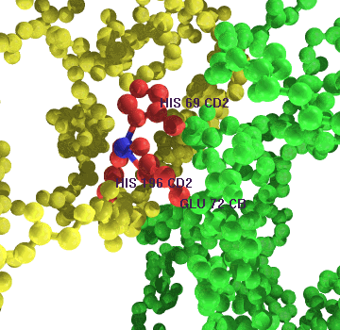

Figure 1. The bond between the zinc ion and his 196 connects the two catalytic functional domains of carboxypeptidase A so that relative motions of the domains are converted into electronic details of the bond thus modifying those of the ion.
Figure 2 Carboxypeptidase 5CPA showing B factors and residue numbers against atom numbers. The two catalytic domains are joined at residue 133 as the center of symmetry. Two of the zinc ligands, his 69 and glu 72, from the first functional domain meet his 196 from second to chelate the zinc ion. Matrix contraction forces temporary distortion of the ligand field probably to effect temporary ionization of a water molecule that completes Zn ligation. The catalytic mechanism is the standard “nutcracker”. Ligand geometry changes in that process are no more than a few tenths of an angstrom.
The step from serine proteases to carboxypeptidase involves only a change in chemistry by replacing the proton in the inter-domain hydrogen bond by zinc ion so as to take advantage of the adjustability of the ligand field at zinc by conformational changes. The next degree of sophistication really a very small change in mechanism but a considerable advance in evolution is to replace the metal ion by another coenzyme such as NAD+ in the malate dehydrogenases as shown in the following two figures. The only difference is that NAD+ is substituted for one of the usual chemically functional groups without change in geometry so the redox group of the coenzyme extends into the inter-domain crevice to meet the imidazole companion from the other functional domain.
Figure 3. Malate dehydrogenate B plot. IEMD.PDB has both NAD (red) and the substrate isocitrate (blue) bound. The geometry is shown in the following figure.
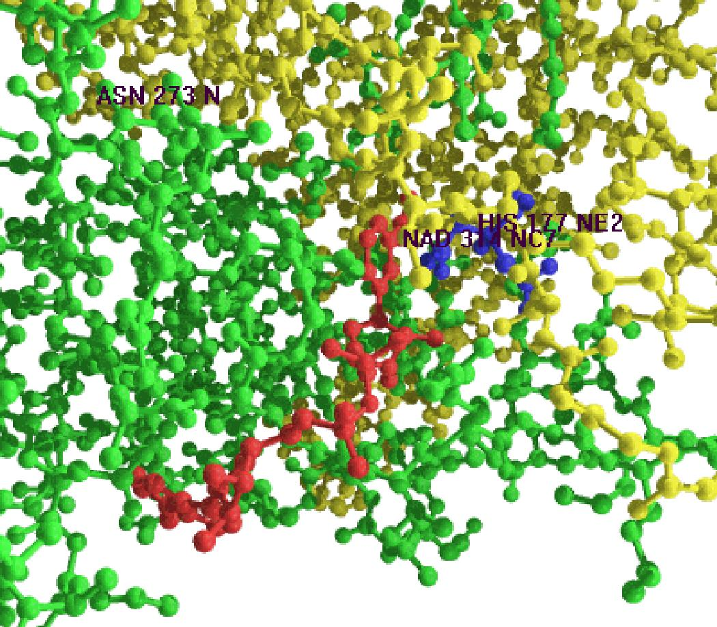
Figure 4 Malate dehydogenase with NAD+ and CID bound. Two equal functional domains. Coenzyme and substrate both in N-terminal domain have matrix B values. The C-terminal domain contains his 177 as its single functional group. This is a mesophile.
Malate dehydrogenase resembles trypsin and carboxypeptidase A in having two domains of the same size and general B-factor similarity. The pyridoxy-phosphate enzymes studied by C-H. Chen have the standard construction except that the coenzyme hangs initially from the middle residue and thus at the center of the hinge between the two functional domains. In function that group moves at least twice to complete catalysis and return to the initial state. Each contraction-expansion of a matrix when not locked into the contracted state occurs in about 1n and is similar to a clock tick of the processer in a small computer. The pyridoxyl-phosphate enzymes may have an operation cycle of two or three ticks and there is not any obvious reason why evolution has not found multiple-ticke processes acceptable. Vitamins and other coenzymes may reveal other variants on the nutcracker mechanism to support different chemistry with complications too difficult to be obvious at our current level of study. The basic construction and nutcracker mechanism is preserved in all cases we have thus far examined... Binding of NAD+ obscures the palindrome in the N-terminal domain but the near C-2 symmetry is clearly apparent. The dehydrogenases introduce new elements of sophistication in evolution. Since they undergo chemical changes in function, change in redox state in particular, they are much more than pure catalysts. They must work as well in reduction as in oxidation depending on the substrate and free-energy change. In addition they solve the two-electron problem in oxidation-reduction to illustrate how evolution has found coenzymes to support different kinds of substrate reaction. In this example NAD+ is used to extract one proton and one electron from CID. The nicotineadenine ring is thus reduced in a two-electron process. Histidine 177 on the C-terminal domain meets that terminal NAD+ group across the interdomain cleft and is apparently the second functional group. Matrix contraction forces domain closure thus providing temporary increase in the free energy of the pretransition state. The molecular involvement of the remainder of the cofactor beyond its role in tethering the cofactor to the N-terminal domain is not obvious in this example but its union with the protein provides a versatile means for cooperative storage and redistribution of free energy in matrices .Some examples are given in Chapter @.

