Chapter 17. Mechanical features of chymotryptic catalysis
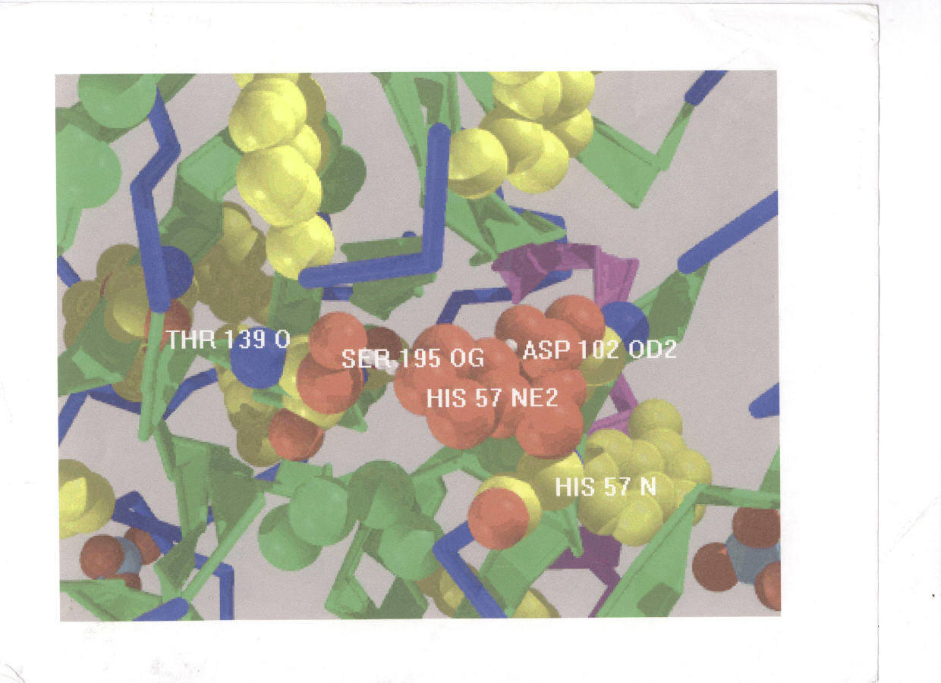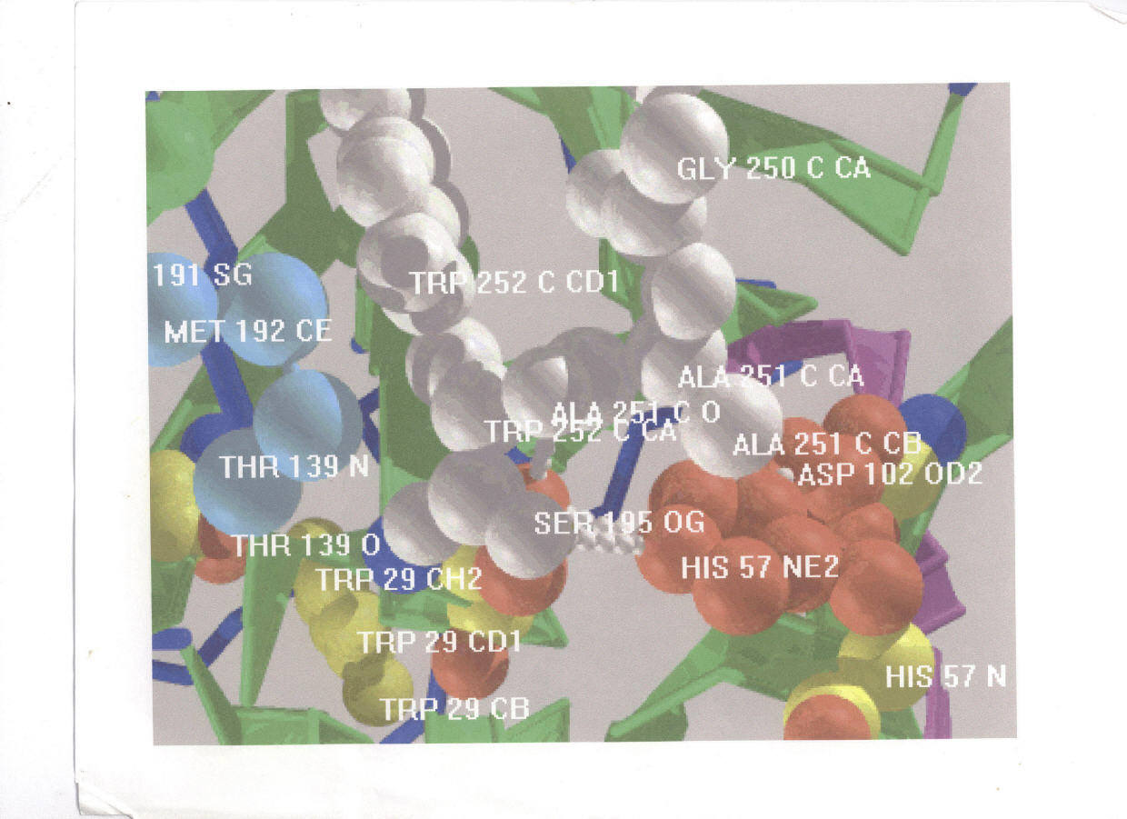
Figure 1. The picture at the top shows the single critical hydrogen bond (his 57 to ser 195) between the two functional groups of chymotrypsin in the absence of a substrate analog. That at the bottom has bound in the substrate site a substrate analog (gly, ala, tryp.) to show close association of the bond and the substrate so both are distorted by domain closure. Shortening the H bond in formation of the pretransition state facilitating proton transfer thus activating proton relocation steps in this case of acid catalysis. Compression forces distortion of the reactive bond in the substrate both effects being important in substrate excitation and both apparently common. The low-barrier hydrogen bond so much discussed is produced in this way and has little occurrence in the free enzyme. The degree of compression of the critical H bond varies with substrate and inhibitor. Zundel shows for example that the very tighty bound inhibitor of pepsin, pepstatin, forces complete proton migration across the bond. The changes in bond lengths do not exceed 0.3 Å

Historically the second application of the rack concept was to chymotryptic catalysis in which the major force was supposed to arises from matrix contraction and to effect destabilization of pre-transition states through domain closure by compression something like an office stapler or pair of scissons but with the force generated internally rather than externally. Scissors is a better analog because they have approximate C-2 symmetry and cut on closing of the two blades. However Corloni’s term “nut-cracker” is even more apt.
Subsequent study has shown that the matrix-contraction process is cyclic started by selective substrate binding that alters the matrix enthalpy-entropy balance from the strong entropy control in the free enzyme to an almost isoergonic balance of energy and entropy. As the matrix potential energy falls, that of the pretransition state rises. This is conventional chemical transfer of free energy via change in primary bonding through change in modes parameters rather than exchange in primary bonding. In contrast to “transition-state-stabilization” that depends on lowering and broadening of the potential-energy barrier, mechanical mechanisms raise the potential energy of the pretransition state toward that of the transition state. This latter is not obvious in the measured values of Eyring’s rate-theory activation rate parameters since the activation free energy as calculated from the observed rate is small relative to the large free energy difference between the average reactant and the true transition state. Because there is little change in total potential energy during the conversion of average reactant to pretransition state, only the entropy change contributes in major way to the apparent activation free energy. This also makes the apparent activation enthalpy low. These quantities so useful for thermal-activation are misleading and virtually useless for mechanical activation.
In the pretransition state for proteases and other enzymes depending on acid-base catalysis the reaction barrier is narrowed so that transition processes depending on the probability of proton, H atom and hydride-ion migration, common transition-state activities in many kinds of enzymes, are increased. The popular term “low-barrier hydrogen bonds” is unprofitable because such bonds occur only under domain closure and are thus not only transient but vary in the extend of proton transfer depending on substrate and enzyme. The greater the narrowing, the greater is the overlap of donor and acceptor orbitals of the H bond. Destabilization of the pretransition state must be transient to avoid protein denaturation and estimates of the lifetime range about 1 ns more than sufficient time for reaction from the pretransition state through the transition state with minor thermal activation and generally much too short for denaturation.
Mechanical mechanisms replace limited thermal activation by unlimited mechanical activation. In principle any amount of work can be done to form the pretransition state simply by increasing the size of properly selected matrix substructures. But a more effective device is to direct the force vectors along the reaction coordinate. An early estimate and one probably correct is that chymotryptic catalysis has and enhancement factor of ten orders of magnitude relative to homogeneous base catalysis. Estimates from Yapel’s systematic study of substrates and inhibitors for this enzyme are 15 kcal reduction in enthalpy with little net disadvantage from lost entropy consistent with that enhancement. That amount seems a small achievement for the complicated strictures but is equivalent to ten orders of magnitude if the force is optimally directed along the reaction coordinate.to form the pretransition state. Note that specificity is determined as much by direction of force vectors as by specific geometry in protein-substrate binding. A wide range of subtleties in substrate specificity is available by choice of vector direction and scalar value, a choice directly adjustable by DNA changes for each substrate and inhibitor. The HIV-1 protease keeps one step ahead of the pharmacologists by single residue mutations.
At this time the mechanical mechanisms appear to be consistent with the construction of enzymes. The low-B palindrome establishes the basic C-2 scaffold symmetry as well as genetic continuity and folded stability leaving matrices adjustable for physiological function unrestrained by exact C-2 symmetry. Matrices tend toward that symmetry particularly as they contract toward their glassy states but contraction can be so large that the protein approaches a glassy state of near uniform matrix free volume .Contraction is cooperative and directed toward the center of the palindrome and so generates roughly ellipsoidal shells of constant B about that axis. As shown by the diagram for the HIV-1 protease in $Fig. 15 @ an enzyme with identical subunits for its catalytic domain pair has oppositely directed coaxial force vectors with the vector heads on the two functional groups so as to generate equal and opposite forces on those groups. That arrangement maximizes the work done on those groups by matrix contraction but limits specificity in substrate selection to molecules that can be held perpendicular to the common plane of the functional domains. Enzymes with non-identical catalytic domains have similar vector pairs but these must generally deviate from co-linearity in the vertical plane. That accommodates structurally more complex substrates also giving a wide range of vector directions but tends to reduce the maximum force on reacting assembly. The free-volume changes in matrices during domain closure can be followed in a somewhat hit and miss way with B factors for inhibitors of various types and pseudo substrates like the acylenzyme species of the trypsin family of proteases. At present unguided protein engineering” simply confuses this undertaking because single residue changes often have wide ranging effects on B factors determinable only with systematic studies not yet begun or generally contemplated. As shown elsewhere residue selection encoded in the DNA is subject to much greater restriction than is generally appreciated. Knot modifications are usually easily measured by changes in stability but that is rarely the case for matrices. As already observed, very few of the subtleties of residue exchange are detectable in coordinates from x-ray-diffraction study. With the best present diffraction methods such changes as they do produce are too small to be quantitatively useful. For example they are too small to give precision in potential-energy diagrams necessary to obtain hard information from supercomputing. Fortunately in addition to B factors a number of “conformationally sensitive” experimental methods provide good measures of the extent of “subtle changes”, deep uv CD, amide infra-red and raman spectroscopy, density to name a few.
Evolution has found ways to effect improvements far exceeding those available with small molecules and the major mechanisms appear to be mechanical as suggested fifty years ago and now well exposed for enzymic catalysis by the domain-closure device. Biology has apparently been possible only with mechanical mechanisms. Matrices as potential-energy reservoirs replace thermal activation of rate processes. That appears to be the major success in building large protein molecules. Destabilization of pre-transition states is a much more powerful catalytic device than the still popular “transition-state stabilization”.
The high cooperativity and strength in knot formation is due to the synergism of free volume and local dielectric constant producing exceptionally strong hydrogen bonds perhaps with considerable covalent character. The fine details of matrix and knot construction providing both cooperativity and selectivity are a result of very low tolerance in residues selection. Specific substrates for enzymes complete a knot or a matrix to lower the system free energy both by new direct contacts and by triggering free-volume rearrangements that may extend over most of the matrices. Accidental triggering is restricted by the very severe requirements for groups to provide just the required atoms to complete a knot or matrix but the “entactic site” proposal of Williams and Vallee long since well established indicates that random matrix contraction producing non-specific catalysis occurs without specific triggering.

