Chapter 18. Construction for function- The subtle-change process
D’Arcy Thompson in 1917 stated that “Form is a diagram of force.”. Enzyme catalysis appears to be an excellent example of this dictum. The mechanical device responsible for the successful evolution of enzymes is probably always the free-volume expansion and contraction process originally called the “subtle-change process” although it is subtle only because it is rarely detectable in x-ray coordinate values even in these days of high resolution. It is nevertheless the basis of high efficiency and high specificity in enzymic catalysis. In chymotrypsin the potential-energy transfer raises the free-energy of the pretransition state reducing the thermal energy necessary for the final jump through the transition state itself. Different combinations of pretransition free-energy enhancement and thermal activation provide a distribution of paths to the transition state as the contraction process matches the requirements for each specific substrate. Each such combination for a given substrate generates a different pretransition state and a different turn-over rate constant, usually called k _{cat} so that parameter characterizes a distribution .Experimental enzyme rate data can probably be fit by historical formal mechanisms but doing so conceals important sophistication. The steady state process catalytic process is cyclic returning the protein to its free state only because of the chemical change from substrate to product. On the other hand specific inhibitors unable to make a chemical conversion move past the reaction point on the coordinate and so become more deeply embedded in the protein for slow reversal. A free-energy surface for chymotryptic catalysis , Fig. @, illustrates these details but not the characteristic times. Productive substrate binding is rapidly reversed as is binding of D enantiomers of good substrates. Progression along the reaction coordinate toward the right past the point of chemical combination between enzyme and substrate is slow to reverse. .Good inhibitors are fragments of substrates and frequently move into the right region. We suspect these details are quite common and have led to much confusion in attempts to interpret enzymic rate data.
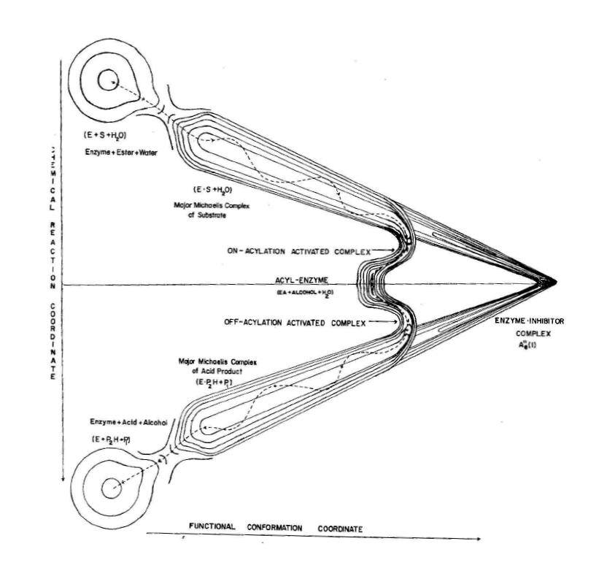
Figure 1Free-energy surface for chymotryptic catalysis. This surface includes an acyl-intermediate formed by acylation of serine 295 by the acid fragment os the ester or amid substrate.(From Lumry and Biltonen, Structue and stability of biological macromolecules, Timasheff-Fasman, Dekker, 1970.
The comparison of “productive”and “non-productive” binding of a nucleotide by ribonuclease A shown in Fig. @ is a good example since the non-productive binding is the deep binding and in this example is tightens the matrix into a uniform ball with B values not much higher than those of the knot atoms.
Figure 2. Fig. @ Free-volume changes produced by productive and non-productive binding of uridine @ by bovine ribonuclease. Volume reduction is somewhat exaggerated by communal effects in contraction. Productive binding is thought to correspond to true substrate binding but that seems unlikely (see text). The abscissa is the atom B factors for non-productive binding and the contraction is change is roughly linear in these atom B factors. Non-productive binding produces only a scale change. Note that non-productive binding eliminates most of the matrix free volume although the inhibitor is only partially embedded in the protein. In the productive complex form found only if the single sulfate group is bound to protein the enzyme collapses about the entire nucleotide.
With this description inhibitor binding is true equilibrium processes but normal catalysis may not obey either the microscopic-reversibility principle or that of detailed balance. The mechanical mechanism for catalysis it not well described by the term “rack” and Corloni et al have recently suggested the more correctly descriptive term “nut cracker” which implies the step from pretransition species to transition state is irreversible. This does not appear to be unlikely but requires a profound reexamination. That enzymic catalysis is not strictly reversible was show by Wyman in his discussion under the title “The turning wheel” since that theory is applicable to reformation of the native free enzyme by a non-equilibrium process. With this possibility in mind consider Yaplel’s data for chymotrypsin in more detail.
Binding of substrates and inhibitors depends on the extent of matrix contraction as revealed by B values, ORD spectra in the peptide bands near 200nm , increased fluorescence yields. Again chymotrypsin provides an illustrative example. Yapel measured the accessibility of the two histidine imidazole rings to proton exchange with dissolved phenol red. For the parent substrate N-acetyl-L-tryptophan ethyl ester he founds that indole and N-acetyl-L-tryptophan block the access so he could evaluated equilibrium complexes with that enzyme and these gave entropy changes of -65 cal.MK and -130cal/MK ,respectively , large unfavorable contributions to the standard free energy changes. The spontaneous reversal time is the order of 1s. N-acetyl-D-tryptophan produces only –25cal/MK and decomposes in 10 microseconds. The first two are competitive inhibitors and trigger the conformation change. They are not substrates; if they were , they would have reacted in milliseconds long before their deep binding as inhibitors occurs. However acids like N-acetyl-L-tryptophan are virtual substrates defined as acids in which the carbonyl oxygen is exchanged with oxygen from water. This occurs only with the free acid form. Oxygen exchange in the enantiomers does not occur as would be expected with a nut-cracker mechanism.

Yapel’s result distinguish true substates, competitive inhibitors and simple non-specific ligands not tightly bound and producing small changes in fluorescence, ORD etc. consistent with only small changes in conformation. Strong acylating reagents such as the nerve gases have provided much information about conformation changes. A more systematic investigation has used the p-ntrophenyl derivatives of the linear aliphatic acids from acetic to caproic since they spontaneously form the acyl derivatives with the serine proteases. Cane and Wetlaufer found major changes in conformation parameters as the chain size increased. There was no significant change in the rate of hydrolysis to the free-acid product. but progressively increasing values of activation enthalpy and entropy yielding a compensation plot with compensation temperature of 280K. Subsequent studies by Dorovska-Taran and Martinek and their respective coworkers produced values for the compensation temperatures. Initial contact between substrate and this enzyme is characterized by a value of 220K. Enzyme-substrate compound formation and its conversion to produce in the slow step for primary-bond rearrangement has values near 450K. The competitive inhibitors have values of 280K. Although there are few reports of such information in the literature, those we know of suggest that these numbers apply to many proteins, probably all the mesophiles enzymes. In view of the great similarity of that large class, this is not surprising. For example, there are numerous examples of T_{C} values in the range 430-500K for involvement of matrices just as the mesophiles always demonstrate values of 354K for knots. Data generated in studies of a series of normal ester substrates for chymotrypsin by Martinek et al reveal linear compensation behavior in all the steady-state rate parameters. The catalytic rate constant increased with size of sidechain and the effect is large attributable to the high compensation temperature of 460K because the larger than value the smaller the entropy loss per unit enthalpy loss in matrix contraction. With -lyctic protease acylated with boronic acids having side chains corresponding to the same amino acids diminished the B factors of all the matrix atoms with minor contraction of knots only with the phenylalanyl sidechain@.

These results illustrate the extreme sensitivity of the matrix process in these enzymes to substrate structure showing the entire protein matrix to be involved in catalysis.
Pauling’ famous suggestion that enzymes are so constructed that the substrate is bound in a distorted conformation resembling the transition state for the rate-limiting primary-bond rearrangement has misdirected much of enzyme research insofar as it has been interpreted to mean that passive binding to a rigid protein produces the necessary distortion. Such “transition-state stabilization” has been thought to be supported by the finding of very effective inhibitors called “transition-state analogs” because their effectiveness is thought to be due to their similarity to the transition state for primary-bond rearrangement of substrate. Abzymes may in fact sometimes serve as moderately effective catalysis by this mechanism probably complicated by release of free-energy from the immunoglobulin. For enzymes, however, a better explanation for the “transition-state” acceleration reason is the similarity to the pretransition state. The latter as defined in this monograph has been found in evolution to be close to the true transition states as a result of efficient use of the free energy from matrix contraction. If the inhibitor already resembles the pretransition state, that free energy is not stored in pretransition stress and thus available to increase the strength of interaction with the enzyme.. Since transition state and pretransition state closely resemble each other, the distinction is not a sharp one. However, finding a transition state analog as is often possible simply by examination of the reaction, provides more information about the pretransition state than the transition state. Transition-state analogs are thus very efficient in triggering the matrix contraction process and slow dissociation of true competitive inhibitors from their enzymes are often reported to be slow compared to characteristic times of the catalytic steps. Trypsin and chymotrypsin are good examples. .
It is interesting that as an equilibrium inhibitor indole is sufficient to trigger the contraction process though less effectively than N-acetyl-L-tryptophan and the D enantiomers of the latter produce only a minor change as a result of the initial combination from solution of substrate and enzyme. The L compound is a virtual substrate so must become chemically altered during uptake although not efficiently. Based on Vaslow-Doherty experiments on chymotrypsin the D compound is not a virtual substrate. The several methods for measuring matrix contraction correlate inhibitor and acyl-enzymes with B values to show that specificity and rate in catalysis and inhibitor binding are manifestation of changes throughout the matrices triggered by molecules with the specific size, type and handedness required by the enzyme. The contraction illustrated in Fig. 29 for binding of the same inhibitor in non-productive and productive modes by ribonuclease A is much larger than we expect for binding of a good substrate in its pretransition state but the average pretransition state varies with substrate. So also does the binding of true competitive inhibitors but the degree of contraction depends on the inhibitor. The degree of contraction and loss in free volume produced in the course of catalytic reaction with true substrates goes far beyond the simple hole filling currently favored in the pharmacy industry on which the original lock-and-key hypothesis was predicated. The low dose levels at which most successful drugs are effective are a consequences of very advanced matrix evolution with the result that small changes in drug construction can have major consequences for therapy as can exchanges of single residues in a protein. Although pictorial design of pharmaceuticals using holes revealed by x-ray-diffraction pictures do not engage such problems at a powerful or reliable level, B factors and proton-exchange rates from nmr can provide much of the fine detail actually required to find new protein-dependent drugs. As mentioned, circular-dichroism in the peptide bands below 220 nanometers give direct information about the subtle changes by which such searches can be fashioned. Several other physical quantities give similar information.
Nut-cracker mechanisms are similar to flush toilets Water pressure provides the potential energy released by activating the flush lever and the siphon effect drives the cycle forward to completion. The major difference is the use of conformational potential energy from the expanded matrix but amount available to produce the pretransition state varies with the entropy drop in matrix compression. Hence the amount of potential energy in that state depends on entropy as well as enthalpy and completion of the cycle depends on the reverse: entropy increase in transition-state formation plus return of potential energy to matrix accompanying passage through the transition state. Given the expanded matrix in the free enzyme the degree of contraction and compression depends on the substrate.
Just as knots are the key to understanding structure so subtle changes of matrices are the essential basis for understanding enzymic catalysis. The subtle-change process was the focus of protein physical chemistry from 1960-70 until x-ray structures hid it and simplistic ideas about residue sequence as an adequate source of information came to dominate protein research. The early information no longer attracts attention and must be re-examined but there is such and abundance of complicated experimental data a volume supplementing this one will be necessary. High points.HERE expseicall Cane and comp temperatures. Kuby paper and what else here.

