Chapter 5. Functional domains
BPTI is an example of a large class of proteins which form the smallest complete and generally autonomous protein unit consisting of one knot and its associated matrix and surfaces substructures. These units have been called “functional domains” in an effort to avoid some confusion with other definitions in the literature. Many single-domain proteins have regulatory functions such as the protease inhibition produced by BPTI. Enzymes always contain a minimum pair of functional domains for catalysis and cofactors are often attached in their own functional domains. That broad generalization rests on the fact that we have found no exceptions in some hundreds of enzymes in the Protein Data Bank. Although many studies have too large B errors, particularly the earlier ones in which coordinates and B factors were not refined or not refined together. Because of center of symmetry between the matched functional domains is precise and the B-factor palindrome patterns of knots also precise, accurate C-2 symmetry is very common In the HIV-1 protease the catalytic pair are identical proteins connected by a strong secondary interaction between their peptide tails. Assembly is often modular so that sites for coenzymes and other effectors are sometimes incorporated in their own functional domains. as the calcium ion in phospholipase A2 but not the zinc ion of carboxypeptidase A which is attached between the matched pair by its ligands. There are other uses for functional domains. A common one is to provide the hinge between the functional pair and in some of those examples that new domain participates in the catalytic chemistry.
The ubiquitous functional pair provides the chemistry as illustrated here with the HIV-1 protease.
A 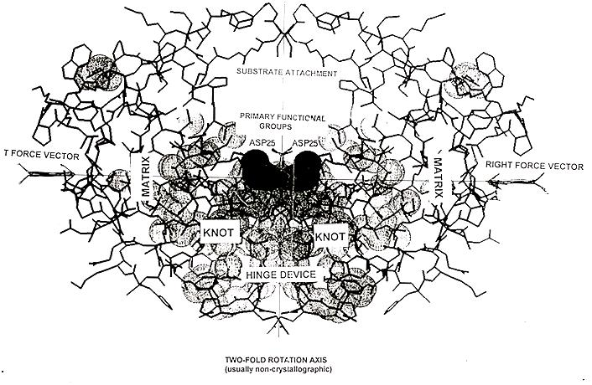
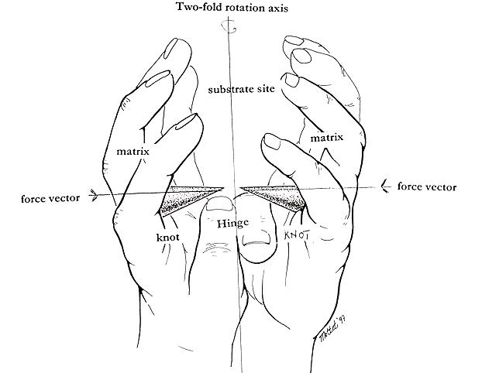
Figure 1. HIV-1 protease structure and catalytic mechanism. The catalytic domain pair are identical proteins connected by a short knot hinge (“fireman’s grip”), Contraction of matrices drives domain closure forcing the two catalytic functional groups into the substrate. Corloni and coworkers have described the changes shown here in some detail using only moleculardynamics computing. (JMB in press May 2002)
In aspartyl transcarbamylase the catalytic domain pairs are combined with sophisticated regulatory units in easily separable proteins. Some enzymes have catalytic domains on separate and different proteins. In these symmetry and other construction details may be different but we have not yet examined the B-factor data for enzymes in this class. Enzymes with multiple pairs of catalytic domains in a single enzyme are discussed in Section @.

