Chapter 8. In knot-matrix proteins the knots are a major basis of folded stability.

The thermal denaturation of a functional domain in dilute buffers is usually found to satisfy tests for two-state behavior in which cases the melting mechanism includes together with one reactant state and one product state only one important transition state .The normal product in dilute buffer not too far from the isoelectric pH and in the absence of the so-called structure-breaking cosolvents; e.g., urea, guanidiniumHCl, hydrazine, has about twice the volume of the native state regardless of any intact disulfide bonds. The small sizes and incomplete random-coil formation in these species at low denaturant concentration was established many years ago and particularly well by Tanford et al now much extended by Bolen and coworkers with high concentrations of structure-breaking denaturants. Of the many studies in dilute buffers the pioneering study of Corbett and Roche using excluded-volume chromatography has been especially unambiguous but each year produces new evidence for the generality of contracted-chain as product. However the most extensive calorimetric studies of denaturation thermodynamics, those of Privalov and coworkers, are interpreted as though major unfolding takes place characterized by extensive direct contact between polypeptide and pure water. Their interpretation apparently based entirely on comparisons of values of thermodynamic change in water with those in high concentrations of denaturants has become a source of great confusion. The product state in dilute buffers as established in many different ways has been called net, balloon and bubble. The last is most correctly descriptive and we will use it. Amphiphiles other than a few very small alkanols form micelles in water with CMC values decreasing with increasing size. The bubble states of denatured proteins form a large class of micelles with very low CMC values. Bubbles might be called protein micelles but that term generally implies some regular and often fixed order. Though technically amorphous because there is no indefinitely fixed internal structure, protein bubbles have high internal motility and often a marked tendency toward transient secondary structure. Further expansion toward true random-coil characteristics, that is, into direct contact of chain with bulk water, occurs only at zero and sub-zero temperatures in dilute buffers and at ambient temperatures only in aqueous mixtures containing “structure-breaking” cosolvents sufficient to destroy the macrostates of pure water. As shown in Section @ the standard free energy change in bubble formation in dilute buffers is very little dependent on the interactions between bubble and solvent. As one result bubbles are osmometers reflecting the activity of water swelling and shrinking with temperature in response to changes in that activity.
The reactant state in melting is the folded native species. Although proteins form normal crystals, their most useful thermodynamic unit is rather the single molecule, one class of Schrodinger’s “aperiodic crystals”. Its phase space is relatively large but much less so than those of single bubble or “random-coil” products. The melting process being first-order and probably generally unimolecular is a single-molecule process in which each protein molecule roughly approximates the average response of a true statistical-mechanical ensemble with two macrostates. Insofar as the protein molecules are independent of protein concentration thus formally ideal, the appropriate distribution function is a simple binomial thus explaining the adequacy of the two-state approximation. At this level melting is a true first-order phase change. However, the single-particle partition functions are complicated by substates not only conformers of the protein but state variations of processes linked to a protein including hydration. Particularly complicating are the expanded and contracted matrix conformers since advancement from one to the other is continuous. These can cause confusion in two-state tests and some differences, often important, in activation and standard thermodynamic quantities. Once recognized these complications can be easily accommodated but the process is not well known and the necessary data are rarely available. Most such complications are of secondary importance in this elementary discussion. Of more conceptual importance is fact that the temperature dependence of polypeptide solubility causes two-state tests to fail in a small temperature region near the temperature of maximum stability of the native state. In this range there are three important macrostates and with knot-matrix proteins in water or dilute buffers all three must be included in any thermal denaturation mechanism after the next introductory paragraphs..
Cooperative behavior in melting is due to the constraints applied by the knots. Cooperative behavior in physiological function is due to matrix construction as dominated by constraints from the knots. In dry and slightly moist native states cooperative melting persists and produces a dehydrated state with glassy characteristics resembling much more the transition state than the wet bubble. Then addition of water produces the wet bubble. The bubble is unstable relative to aggregation and precipitation as β-sheet fibers but otherwise remains the stable product until the temperature is lowered toward freezing and then into the supercooled regime of pure water where unfolding toward true random-coil configurations is favored. The increased solubility at low temperatures responsible for this expansion is an example of “Frank-Evans iceberg” behavior demonstrated in many studies of “hydrophobic-hydration”. Kauzmann suggested that the poor solubility of hydrophobes and amphphiles at the higher temperatures drives any denatured species with major direct exposure to pure water back toward native-state folding. As already noted, this is correct but not relevant to thermal denaturation in pure water because the bubble product has little more direct contact between polypeptide and bulk water than the native state. Extrusion into bulk water becomes significant only below the temperature of maximum stability usually near or below 283K in dilute buffers so Franks and Hadley used supercooling methods to measure the true unfolding process of chymotrypsinogen and some other mesophiles @ in pure water at temperatures well into the subzero regime. These “cold denaturation” data provide the low-temperature arm of the pseudo-parabolic van’t Hoff plot Brandts first found at higher temperatures. Folding from random-coil species to bubble state, often called “hydrophobic collapse”, occurs in pure water only in this temperature region or only in irreversible release from the ribosome. At higher temperatures structure-breaking cosolvents such as urea and hydrazine are necessary to destabilize the bubble state relative to random-coil. This effect is illustrated by the data obtained by Almog, Strier and Strier for transfers of ribonuclease A from dilute buffers to aqueous mixtures with increasing concentrations of structure-breaking cosolvents (Fig. 14.). First the native state becomes destabilized

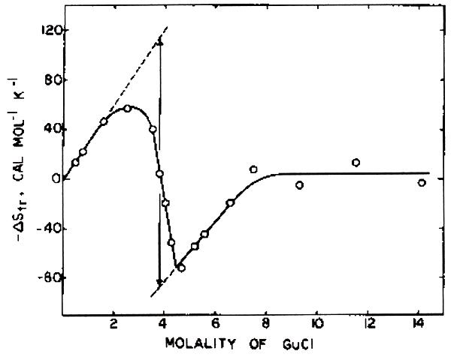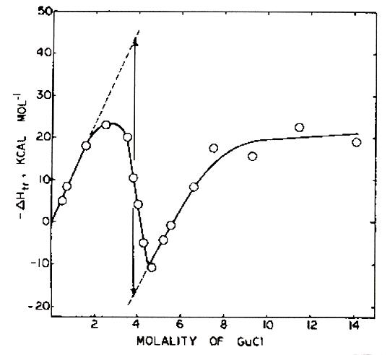 Fig. 12 Standard enthalpy and entropy changes accompanying transfer of ribonuclease A from dilute buffer to mixtures of water with structure-breaking cosolvents of increasing concentration. The data for guandinium HCl are given in this figure. Both steps in denaturation show enthalpy—entropy compensation with transitions temperatures near 290K.

producing the bubble state as stable product. Then the latter becomes unstable with respect to true unfolded forms because the cosolvent converts water to a strongly associated liquid like hydrazine, Frank called “inhibited” water. Almog and coworkers using ribonuclease A found the same pattern of behavior with urea as cosolvent and similar patterns with structure-breaking electrolytes: e.g. LiCl and CaCl ₂. Although some binding of urea and guanidiniumHCl by protein is though to occur, the major effect of these “structure-breaking”cosolvents depends on their ability to destroy pure-water states so it not surprising that data obtained with such additives have little relevance to behavior measured in the their absence. The effect is well illustrated by the measurement of apparent surface areas for this protein by Volynskaya, Kasumov and Shiskov. They confirmed our interpretation of the data of Almog et al given above and added much detail about the changes in surface area and volume produced at the two stages of unfolding on increasing urea or guanidinium·HCl concentrations. For ribonuclease A the transition from native to bubble state and from bubble to random-coil state with each denaturant occurred over Almog’s concentration ranges. In agreement with Corbett and Roche the bubble state has nearly the same volume in guanidiniumHCl as in the native state and the bubble in urea was about 50% larger. Volynskaya et al do not distinguish between bubble and molten-globule states but they did detect separate melting processes for the two functional domains identified in the studies of alcohol-water mixtures of this protein by Brandts, Liu and by Battstel and Bianchi. These domains are illustrated in Fig.@.
Other complications continue to exist because of the term “hydrophobic bond” is often taken to refer to dispersion interactions among non-polar side chains inside folded proteins with “hydrophobic cores” being dispersion clusters. The interaction might better be called the “butter bond” because of its dependence on the very weak cohesive interactions in butter. Compare the vapor pressure of pentane with that of water at room temperature. Oily groups are important in stabilizing native folding not because their van der Waals associations are strong but because they cluster together in knots and in matrices to improve packing about the knot hydrogen bonds, reduce permanent polarization and minimize steric interference with hydrogen-bond formation . They deform easily for better packing and the weak cohesion among such groups in matrices facilitates coordination of free-volume changes as in the ubiquitous expansion-contraction process of matrices.
The enthalpy and entropy changes accompanying bubble formation from the native state are large and positive consistent with some relaxation of the amorphous polypeptide when plasticized by water plus the cost of the transfer of water from bulk phase into the bubble. Neither bubble nor unfolded states are sharply defined. Bubble sizes and conformational motility are particularly sensitive to their proportions of polar to non-polar groups, total ionization as well as number and position of disulfide cross-links. The large positive standard entropy changes in formation from native species establish a high sensitivity to temperature and because there are so many ways to arrange amorphous or random-coil polypeptide with water both bubble and random-coil species have large, positive intrinsic heat capacities. Even higher heat capacities are found at the bottom of the van’t Hoff plot. There the standard enthalpy and entropy changes in bubble formation and those in unfolding from the bubble have opposite signs so that near equal populations of the two species the standard heat capacity change is very large, a matter of popular interest and also much misunderstanding. The following examination of melting at the bottom of the van’t Hoff plot explains the way this comes about.
In order to interpret the apparent thermodynamic changes near the temperature of maximum stability native (N), bubble (B) and random-coil states (U) must all be taken into account. Thus instead of N↔U we need as a minimum N↔B↔U in which B is the bubble species. Generally B has been confused with U, the true but rarely observed unfolded state or states. For simplicity the mechanism below ignores the glassy substate of A and the temperature-dependence of the transition temperature between B and U. Also note that for complete treatment of B↔U it is necessary to add the linkage to the two-state equilibrium of pure water and in addition linkage to the hydration equilibria of the B species.
The standard heat-capacity change in is large and positive but the activation heat capacity is very small so the total standard heat capacity change takes place in hydration and expansion of the transition species to bubble state. However, at lower temperatures the concentration of U becomes significant with respect to that of B. In that temperature range the standard heat capacity still positive becomes very large as the apparent standard enthalpy and entropy changes become negative. The treatment restricted to the melting process is the following in which p is the concentration of total protein.
Conservation of protein:
Equilibrium relationships:
The protein is most stable in native state at the temperature at which the apparent standard entropy change is zero. At that temperature the free-energy minimum is determined by the standard enthalpy changes in the formation steps for B and U as well as the ratio of unfolded to bubble species. Although the van’t Hoff plot is roughly parabolic, the net enthalpy changes near maximum stability are small because the two standard enthalpy changes have opposite signs. On the other hand the apparent heat capacity change has the usual “between-states” term very large when populations of U and B are similar as they are at the bottom of the curve. That term due primarily to the states of water accounts for the sharp curvature. The revised mechanism removes some of the confusion about the heat capacity changes but in practice since the ratio of unfolded to bubble species is large only below the minimum in the parabola use of the less complete mechanism produces serious errors in analysis of the data only in that region.
In summary the single first-order phase change of melting at higher temperatures is replaced by the unfolding change as B goes to U and in the region of overlap at the bottom of the pseudo parabolic curve the two-state melting behavior is replaced by three-state behavior and then back to two-state behavior on further cooling. The expansion of the bubble into the manifold of U states on lowering temperature can be abrupt for a larger protein but the cooperativity in the formation of U from N is the same as that for B from N, a weak first-order phase change following the single transition state.
In dilute buffers at ambient and higher temperatures scanning calorimetry measures only the N↔ B process and the data give no information about the water-polypeptide interaction responsible for most of the thermodynamic changes in folding from ribosome to N. Long polypeptides on separation from ribosome collapse into bubbles, the “hydrophobic collapse”. The formation of the transition state from B leading to the native species is possible only for polypeptides that have a path from bubble to native state implicit in their DNA. The passage through the bulk-water stage is somewhat hazardous faced with the possibilities for irreversible aggregation and precipitation. One can understand why chaperones are necessary to effect at least partial folding to native state knots before exposure to highly aqueous solvent mixtures.
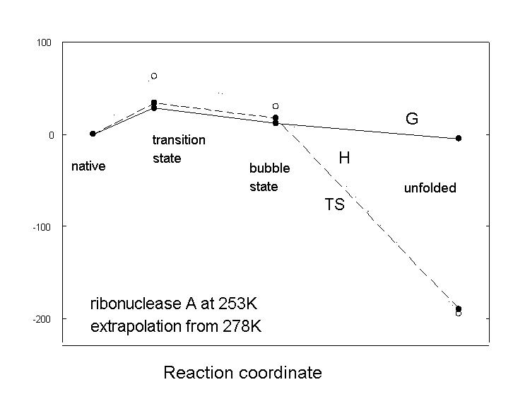
Figure 1.the thermodynamic profiles for melting at low temperatures, the experiment of Franks and Hadley
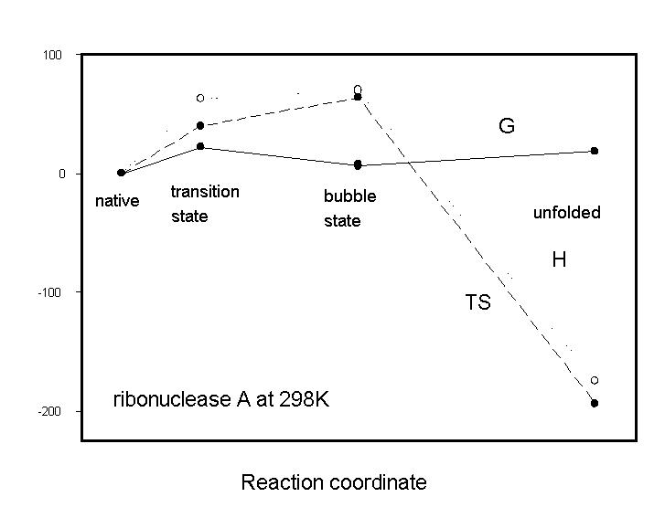.
Figure 2 Melting at ordinary and high temperatures
The profiles for melting at higher temperatures are shown in Fig. 16. The products are different and their formation free energies vary with temperature and solution variables but the activation process for melting is quite insensitive even at low native-state hydration. At temperatures at which the native state is more stable than the bubble state, the activation free energy for melting is larger than that for bubble collapse. These observations show that the process determining the activation free energy for melting controls thermodynamic stability of the native species relative to the bubble state.
The last deduction is inconsistent with the still widespread belief that poor solvation is always responsible for stable folding. Kauzmann’s suggestion that this might be the case made in 1959 is not relevant for melting in dilute buffers since there is little exposure of peptide to bulk water in bubbles. That the products are bubbles rather than extended polypeptides is explained by his suggestion. The thermodynamic situation can be made clearer using the extensive collection of melting data for mezophilic proteins in dilute buffers tabulated by Privalov and Makhatadze. The data reveal accurate linear compensation behavior for the standard-enthalpy of melting again the standard entropy of melting for 13 common mezophilic proteins at temperatures from 283K to 423K.reveal linearity compensation behavior with compensation temperatures, T_{C} , only a few degrees different from the mean experimental temperatures.equal within small errors. Larger differences are found only at the extremes, 283K and 423K. (Table 3.) The variable is
Table 1. Results of fitting linear compensation equations to the data for13 proteins tabulated by Privalov and Makhatadze. When the compensation temperature is near the mean experimental temperature the process linked to actual protein expansion makes negligible contribution to the standard free energy change of unfolding.
the protein index and very nearly the same as the number of residues. The near equivalence of experimental temperature and T_{C}for all but the two extreme temperatures establishes that the linked processes responsible for most of the total standard enthalpy and standard entropy changes are at equilibrium and do not make contributions to the standard free energy changes. Benzinger concluded in 1967 that because this compensation is nearly exact, as it would be if T_{C} were accurately equal to the mean temperature, only a small fraction of bonding interactions are responsible for folded stability
The mean standard free-energy change for the series at each temperature is given by the intercept of the plot on the standard entropy axis. Relative to the enthalpy and entropy changes these are small and their variation with protein within the experimental error. Bubble formation involves change of hydration both internally in mixing with the labile polypeptide as well as external interactions. The standard free energy changes at these temperatures must be due to knot disruption and reorganization of secondary interactions to form the bubble. Bubbles are osmometers so the amounts of water they hold and thus their average sizes vary with the chemical potential of water.
Biltonen first noticed that since the activation heat capacity for melting is zero within small errors, the large standard heat-capacity change occurs after the transition state. A consequence is that the variances of the enthalpy probability-density distributions of the native and transition state are roughly equal. In turn since these heat distributions are dominated by their variances, those heat distributions are very similar. Then the heat change in activation is small and the activation enthalpy measures predominantly changes in potential energy and the zero-point vibrational energies as native state expands into the transition state. The coordinate changes are only small fractions of angstroms so despite the large differences in potential energy in H and degeneracy.in S in molecular detail the transition state resembles closely the native species .These arguments are elaborated in the revision of work by Murphy, Privalov and Gill given in another section.
The free-energy of formation of the native state depends not only on knot strength but also on the B hydration shell, charge distribution, number and positioning of conserved disulfide groups and the stress applied to knots by the matrices. Matrix and knot substructures are in dynamic balance the strong knot spring working against the weak matrix spring so the free energy of formation of the matrix rises as that of the knot decreases. As bubble shrinks toward native state knots the matrix is drawn out of its intrinsic states in the bubble into its stressed state in the native species. The two-state characteristic of folding from bubble states is due to knot selection and kinetic stability is a result of two-state behavior. Most of the very large entropy loss in folding from unfolded polypeptide takes place in assembly of polypeptide on its ribosome so the famous Leventhal entropy contraction is another myth arising from the assumption that the melted state is uncoiled in bulk water. Low entropy means high information and it is unlikely that there is any increase in information beyond that in encoded in the DNA. Even post-translational modifications are determined at the ribosome level.
In view of the description of the transition state just given the stability of a protein is best measured by the activation free energy. This is not the case for proteins that do not depend on knots for stability. There may be many of these but we have not yet found one in our still limited examination of the Protein Database. As a result this review applies to knot-matrix proteins but even with these total knot stability is difficult to estimate because of the work done on the matrices during knot formation. Transfers to bulk water of small models for protein sidechains and peptide groups often used in attempts to model melting do not apply because there is no bulk-phase water in bubbles. Bubble formation after the transition state can be estimated roughly by the standard free energy and enthalpy changes in thermal denaturation of dry proteins in which the standard enthalpy change is much reduced but the phase change remains very sharp and the melting temperature becomes very high. Matrix relaxation toward either its intrinsic states or its hydrated bubble state does not much advance in the dry melting process. Most of the enthalpy change appears in the standard free energy change but not much of the small standard entropy change. Battistel and Bianchi using ribonuclease A have shown that the thermodynamic behavior is not an artifact of irreversibility in the calorimetric scan but instead reflects independent denaturation of the two domains at low hydration. Uncoupling of the two catalytic functional domains appears to be a common result of any drastic change in environmental conditions (Cf. Molten-globule section).
Attempts to explain folded stability are often complicated by the assumption of random-coil rather than bubble product but an equally pervasive complication arises from confusion in the meaning of thermodynamic data obtained at constant temperature. In particular it is not generally understood that there is no rigorous connection between a heat-capacity change and the free-energy change. The operational relationship usually cited is a functional and not a simple equality Only the motive parts (potential energy, zero-point vibrational energies, pressure-volume work and degeneracy) of changes in U, H, S and V contribute to a change in A or G so their derivatives with respect to T, P or V are determined by the thermal parts (Q and Q/T) that do not appear in A or G. Heat-capacity changes at constant temperature measure the shape of the heat-distribution and since the latter is independent of the potential energy, so is the heat capacity. Many discussions of protein denaturation have little value because the absence of any heat-capacity dependence is not appreciated. Thus inferences about molecular details of a system based on temperature and pressure derivatives of H, A and V suffer from this discontinuity and degrade to guesswork. Despite these discoveries by Benzinger’s in 1967, many current denaturation studies are devoted to finding just such inferences
Benzinger’s deductions are easily explained but very difficult to accept because they contravene many familiar though incorrect uses of data from isothermal experiments taught in chemistry courses. Consider a process at T and P constant between macrostates a and b coupled in a non-obligatory way to a two-state solvent process 1 and 2.: At equilibrium and the chemical potentials of the solvent species are always equal . The latter condition imposes a constraint on the a/b process such that although populations of 1 and 2 change to produce changes in the enthalpy and entropy, there is no change in the free energy. Any process coupled non-stoichiometrically to the a/b process will remain at equilibrium and impose a similar constraint on the a/b process. What Benzinger noted was that at constant temperature the heat exchange between system and thermostat is always at equilibrium and so it must impose a similar constraint. The heat and potential energy parts of the enthalpy change are independent so as the a/b process advances and heat changes occur in the system heat flows between system and thermostat to maintain the constant temperature established by the thermostat. The standard free-energy change expression becomes
in which the H quantities are the partial molar enthalpies in the lowest allowed states (potential energy, zero-point vibrational energies and PV (0) terms), the S quantities are the partial molar entropies and the Q quantities are the heats determined as usual by fluctuations of the system among its allowed states as .
Because the heat terms are identical in, they disappear and the standard free-energy expression reduces to . The remaining part of the entropy, called “degeneracy” in the previous paragraph is the difference in the logarithms of the Boltzmann-weighted degeneracies for b and a. The two residual parts give the familiar expression relating the standard free-energy change per mole to the constant pressure partition function of Guggenheim, Δ’: once more demonstrating that the heat parts must cancel in the expression for the free-energy change..
Benzinger’s discovery reveals errors, often large, in most uses of thermodynamic data from isothermal processes but remains virtually unknown after more than forty years. As shown below protein melting provides a very good but quite unusual illustration because the melting rate produces pure free energy and the refolding rate produces almost none (cf. sec.@)

C. Huggins, D. Tapley and E. Jensen, Nature, 167(1951),592

